Lecture Week 3 (22 – 26- Feb-2021)

The Time Value of Money (TVM) is a fundamental financial concept that refers to the idea that money has different values at different points in time. It is based on the principle that a sum of money today is worth more than the same sum of money in the future, due to the potential to earn interest, generate returns, or be used for investment opportunities.

The central concept of TVM can be broken down into two key principles:
Present value (PV):
This represents the current worth of a future sum of money. In other words, it's the value of a future cash flow when it is discounted back to the present. PV calculations are used to determine how much a future amount of money is worth in today's terms.

Future Value (FV):
This represents the worth of a present sum of money at a specific point in the future, taking into account a certain rate of return. FV calculations help determine how much an investment or savings will grow over time.
Annuity series
An annuity is a series of equal cash flows, or payments, made at regular intervals (e.g., monthly or annually). The payments must be equal, and the interval between payments must be regular.
Money Time Relationship
- Relationship between time and money is dynamic and continue to change. What people could purchase from say $10 in past they cannot not purchase same goods or services now

- Purchasing power has changed with passage of time. Change has occurred due to changes in the economic conditions of country:

  - Value of local currency compared to dollars (standard yardstick of currency) is indicator of economic conditions of country
  - Inflation: costs of manufacturing goods show a trend of sharp rise in prices of goods and services:
  - Exports vs imports – exports bring $ into country
  - Availability of foreign exchange
  - Reserves in Current Account create a +ve impact in economy of country

- TVM due to its dynamic nature is considered that money available at the present time is worth more or higher than the same invested amount that you would receive in the future due to its reduced earning capacity.

- Any amount of money invested now and earned earlier is better than that earned later in time or the sooner earned or received is better. Time value of money suggests that one earns higher benefits of receiving money now rather than later in time

Money generates more money

- Money generates money mainly through interest.

- Interest is usury or sin in Islam and Christianity.

- In our country banking system has been transformed to Islamic Banking called Modarba

- Principle of TVM suggests that why interest is paid or earned.

- Amount deposited in the Bank or any other institution or given to investor is not kept idle but it is utilized in business. Now business leads profit and out of profit the bank gives share to the depositor called interest rate.

- Interest, whether it is in a bank or debt compensates the depositor or lender for the TVM or time gap. It also highlights that investors willing to delay spending their money now if they expect a favorable rate of return on their investment in the future.

- With the help of Economics it is possible to calculate value of money at given period of time in future and it is also possible to calculate value of money in retrospect ie backward and forward in time

- When calculating present value retrospectively it would be discounted value
While calculation future value it would be interest rate or Compound Interest

- With the help of Tables and mathematical calculations we can calculate present
Future values of investment over 100 years period

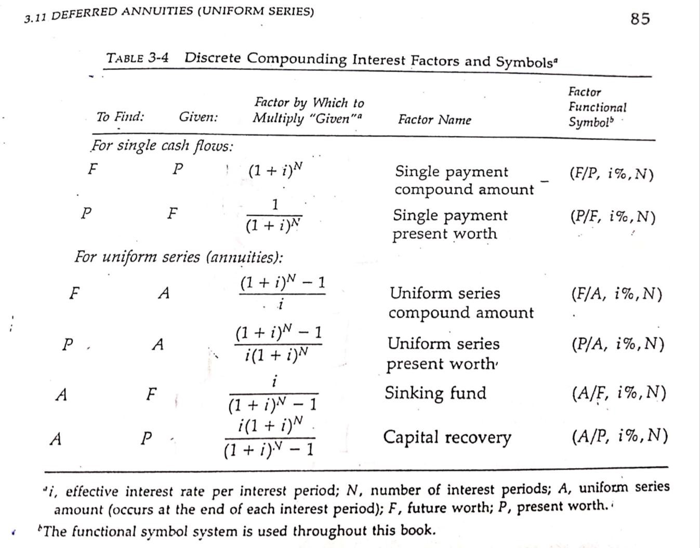

Table
Basic Equations for Time Value Money (TVM)

To Find | Given Value | Formula or Equation | Title | Functional Equation

For one time or single payment cash flow
F P F = P(1 + i)^{n} Single payment (F/P, i%, n)
(Compound

Interest)
P F P = F [1 / (1 + i)^{n}] Single payment (P/F, i%, n)
Present Worth or
Present Value
(PW or PV)

Uniform Series
F A F = A[(1 + i)^{n} – 1]/i Uniform series (F/A, i%, n)
(Compound amount)
P A P = A[(1 + i)^{n} – 1]/ i(1+i)^{n} Single payment (P/A, i%, n)
present worth
A F A = F[i / (1 + i)^{n} – 1] Sinking fund (A/F, i%, N)

A P A = P[i(1+i)^{n} / (1 + i)^{n} – 1] Capital (A/P, i%, n)
Recovery

Abbreviations

P = PV or PW = Present Value or Present Worth
F = FV or FW = Future Value or Future Worth
A = Annuities or Uniform Series (equal amount over equal period of time) n = Time Period
i = Interest or Discount Rate for either single payment or uniform series or Annuities or gradient series
F/P = To find P
Given P
P/F = To find P
Given F
SV = Salvage Value or income earned from resale

Present Value (PV), Future Value (FV) for Single Payment

Formula
- P = F (1 + i %)^{-N}
- F = P (1 + i %)^{N}

Problem. 1. Find the PV of following amount received at the given time period from today discounted at given rate:
Amount FV  ($) | Discount (%) | Time Period (Years)
7395 | 12% | 7
1234 | 7% | 5
1234 | 5% | 7
3497 | 1% | 10

Solution:
Amount FV  ($) | Discount ( %) | Time Period (Years) | PW or PV
7395 | 12% | 7 | 3344.75
1234 | 7% | 5 | 879.8
1234 | 5% | 7 | 879.8
3497 | 1% | 10 | 3165.8

Problem. 2. Calculate FW of following amount at the given time period compounded at interest rate:
Amount PV | Interest Rate (%) | Time Period
2315 | 10% | 15
5000 | 6% | 30
1161 | 1% | 10
5000 | 30% | 6

Solution:
Amount PV  ($) | Interest Rate % | Time Period | FW
2315 | 10 | 15 | 9670.32
5000 | 6 | 30 | 28717.48
1161 | 1 | 10 | 1282.46
5000 | 30 | 6 | 24132.04

Exercises

Problem 1. A firm has sold a building. The firm is going to receive payment in 4 installments. The buyer has paid $ 10,000 at purchase time. The buyers is going to pay $ 15,000, first year $ 18,000, second year $ 21,000, three year later. Find the present value he receives from the rate of the seller wished to use a discount rate of 7%.
To find “P” given F. Answer $ 56,949.

Problem 2. An investor deposits $ 1000 every year on the same day in a saving account. The amounts in the saving account earn 5% interest compounded annually
- what will be the balance in investors account after 3rd deposit.
- what will be the balance in investor’s account after 10th deposit To find “F” given A
(Answer a) $ 3,152 b) $ 2,578)

Problem 3. A woman wishes to have $ 100,000 in her retirement savings plan after working
for 25 years that earns 5% per year. How much must she save each year to achieve the target amount.
To find “A” given F. (Answer $ 2,100)

Problem 4. If a machine undergoes a major overhaul, its output can be increased which translates into extra cash flow of $ 20,000 at the end of each year for 5 years. It i = 15% per year how much can we afford to overhaul this machine now.
Calculate PW or PV
To find “P” given A. (Answer $ 67,044)

Problem 5. What is the PW or PV or P of annuities or uniform series of income of $ 10,000 every 6 years? The Discount rate being 8%.
Clues: | To find “P” given A. (Answer $ 46,000)
Problem | 1) To find “P” given F.
Problem | 2) To find “F” given A
Problem | 3) To find “A” given F.
Problem | 4) To find “P” given A.
Problem | 5) To find “P” given A

Cash Flow Diagram

- Cash Flow Diagram helps top management to easily understand transaction of Cash – inflow, Cash –outflow over a period of time.

- A horizontal line is drawn called Time –Scale.

- Time Scale is divided in to years and moves from left to right and is labeled as 0, 1, 2,
3,- - - - -

- End of Year 1 is start of Year 2.

- Cash inflow (income) is shown by upward arrow including SV which is also income or cash inflow.

- Cash outflow (like investment disbursement, payment, expenses) is shown by
downward

arrow or cash outflow.

0

Cash inflow

Time
-

Scale

Years

1 2 3 4 5 6 7 8
Cash Flow Diagram

Problem

An investment of $ 25,000 is made that produces a uniform annual income of $ 5,310 for 5 years and then have a +ve SV of $ 500 at the end of 5th. The O&M Cost is $ 3,000 per year period of project is 5 years.

